THE LIFE

Mike Harding was born in Crumpsall, Manchester, in 1944, into a working-class Irish-Catholic family.
His father was killed returning from a bombing mission just 4 weeks before Mike was born. This had a profound effect on his childhood and later life, and provided the inspiration for his haunting song Bombers’ Moon. Much of the inspiration for his writing comes from his early years growing up in Manchester.
His ability to commit those memories vividly to paper was encouraged by his English teacher at St. Bede’s School, Father “Foxy” Reynolds, now sadly dead, but whose teaching Mike will never forget.
Throughout his early years Mike developed a love for music, playing in Skiffle and Rock bands in the 60’s. He has fond memories of sharing the bill with The Beatles, Gerry and the Pacemakers, The Hollies, Wayne Fontana and the Mindbenders and the late Eric Spanner and the Rhythmaires.
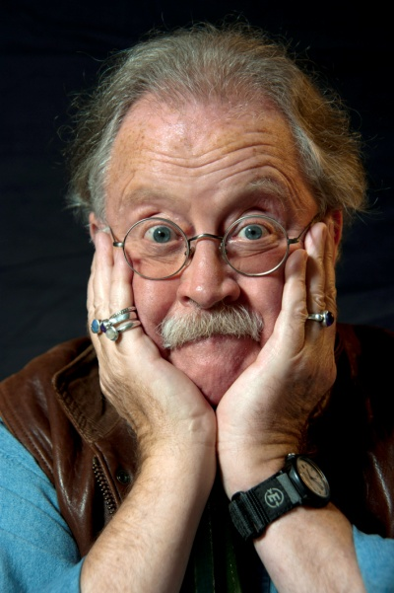

Among his early musical influences, Mike lists Lonnie Donegan, Jesse Fuller and Lancashire folk-singer, the late Harry Boardman. Mike served his apprenticeship in the pubs and clubs of Great Britain and still joins in sessions in Manchester’s Irish pubs if he gets half a chance!
After a chequered early career as dustman, bus conductor, road digger and carpet-fitter, Mike took a degree in Education, paying his way by working at night in Folk Clubs. Finally, the lure of the bright lights proved too much and he became a full-time entertainer instead of a teacher. His success as a live entertainer began in 1967 when, during a gig at Leeds University with The Edison Bell Spasm Band, he began to tell jokes to fill in the awkward pauses while the band tuned up. The patter became part of the act and when the jokes dried up he delved into his store of real-life stories for which he has become famous.
In 1975 the record ‘The Rochdale Cowboy‘ flung him from folk music into the mainstream of live entertainment with his own regular TV series and radio work that continues to this day. He also began a 20 year succession of concert tours with his unique mix of comedy and music, visiting virtually every major venue in the country as well as tours to Australia, Hong Kong and the Middle East. Over the same period he made over 20 albums which still notch up impressive sales to his legion of committed fans.
By the mid-nineties Mike had largely abandoned public performances to concentrate on writing and broadcasting, and to indulge his love of fell-walking and fly fishing. He’s since earned widespread acclaim for both the quality and breadth of his work with over 40 books and plays published.
His writing has ranged from comedy to church architecture, from poetry to playwriting, from short stories to novels and, unsurprisingly, from fell-walking to a manual for fishermen on how to tie flies, with many of the books illustrated with his own photographs.
For 15 years he presented his highly-praised Folk, Roots and Acoustic Music programme on BBC Radio Two, establishing a regular evening audience of a million listeners until he was replaced as presenter a year ago because the BBC wanted the music to be more in tune with Radio 2’s daytime output.
Now he presents his own Mike Harding’s Folk Show on the internet, where he’s building a big audience through live transmissions on Sunday teatime and subsequent podcasts. To listen click on http://www.mikehardingfolkshow.com
A further change in his pattern of work came four years ago when he was enthused by an ad-hoc performance in a village hall near his home in the Yorkshire Dales and decided it was time to go back on the road. With some trepidation a try-out tour of arts centres and little theatres was arranged. Publicity was limited but the outcome surpassed all expectations with sell-out audiences and virtually all venues asking for a second night before the tour had even started.
Subsequently Mike undertook three more tours to increasingly bigger venues with much the same packed-house response, proving that his fans had certainly not forgotten him.
He’s not abandoned his writing however with recent publications including a new collection of his poems - his fourth - under the title: “Connemara Cantos” and “The VW Camper Van – A Biography”. He’s also written a new play, “Coming in on a Wing and a Prayer” inspired in part by the death of his father in a Lancaster bomber.
In fact he decided that 2014 would be the year he shelved his comedy tours for the time being and concentrated instead on his writing, with occasional visits to literary festivals to read his poems to live audiences. This began with a sell-out performance at the Georgian Theatre, Richmond, as part of the Swaledale Festival and included visits to Stratford Poetry Festival and the Shetland Bookfest.
Mike’s latest tour in response to his visits to literary festivals is “An Evening of Poetry” at little theatres and arts centres in the North in May 2015.
Although born and raised in Manchester, Mike’s lived in the Yorkshire Dales for the past 44 years - a lot longer than he lived in Lancashire. The move - in 1971 - was prompted by his love of fell-walking, fly fishing and the countryside in general.
With the Dales as his base, Mike walked and cycled and photographed and lived among the farming community. He became President of The Ramblers for a 3 year term and is now a lifetime Vice-President. He is in constant demand to speak on environmental and ecological issues and has been elected a Fellow of the Royal Geographical Society.
And he’s even been known to admit that there are times when he wishes he’d been born a Yorkshireman.

